**2.Demonstrate how to create the first API request.**

Send your first API request:

Postman's built-in API client enables you to create and send API requests, including HTTP, GraphQL, and gRPC requests. Using Postman, you can send a request to an endpoint, retrieve data from a data source, or test an API's functionality. You don't need to enter commands in a terminal or write any code. When you create a new request and select Send, the API response appears right inside Postman.

API requests defined

APIs provide a structured way for one application to access the capabilities of another application. Typically, this communication happens over the internet by way of an API server. A client application (like a mobile app) sends a request to the server, and after the request is processed the server returns a response to the client.

A request includes the URL of the API endpoint and an HTTP request method. The method indicates the action you want the API to perform. Here are some of the most common methods:

GET retrieves data from an API.

POST sends new data to an API.

PATCH and PUT update existing data.

DELETE removes existing data.

Send an API request

Make sure you've [downloaded and installed the Postman desktop app](https://learning.postman.com/docs/getting-started/first-steps/get-postman/). When you're ready, open the Postman desktop app and send your first API request.

Select + in the workbench to open a new [tab](https://learning.postman.com/docs/getting-started/basics/navigating-postman/#tabs).

Enter postman-echo.com/get for the request URL.

Select Send.

Postman displays the response data sent from the server in the

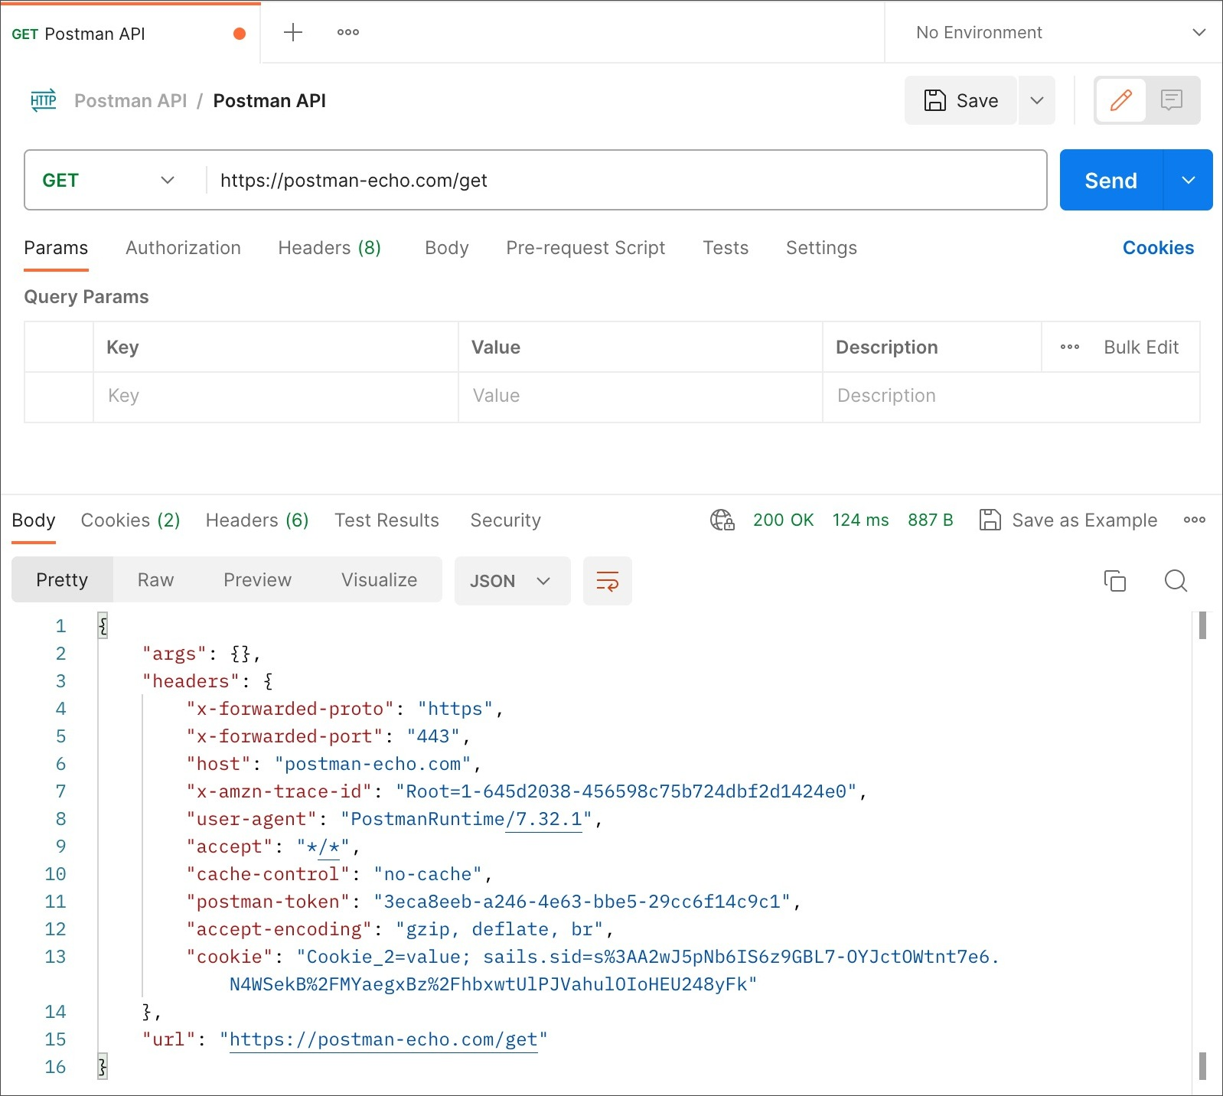

What happened?

In this example, Postman is acting as the client application and is communicating with an API server. Here's what happened when you selected Send:

Postman sent a GET request to the [Postman Echo API](https://www.postman.com/postman/workspace/published-postman-templates/documentation/631643-f695cab7-6878-eb55-7943-ad88e1ccfd65?ctx=documentation) server located at postman-echo.com.

The API server received the request, processed it, and returned a response to Postman.

Postman received the response and displayed it in the Response pane.

You used Postman to send an API request and got a response from the API server. It's okay to take a moment to sit back and reflect on how co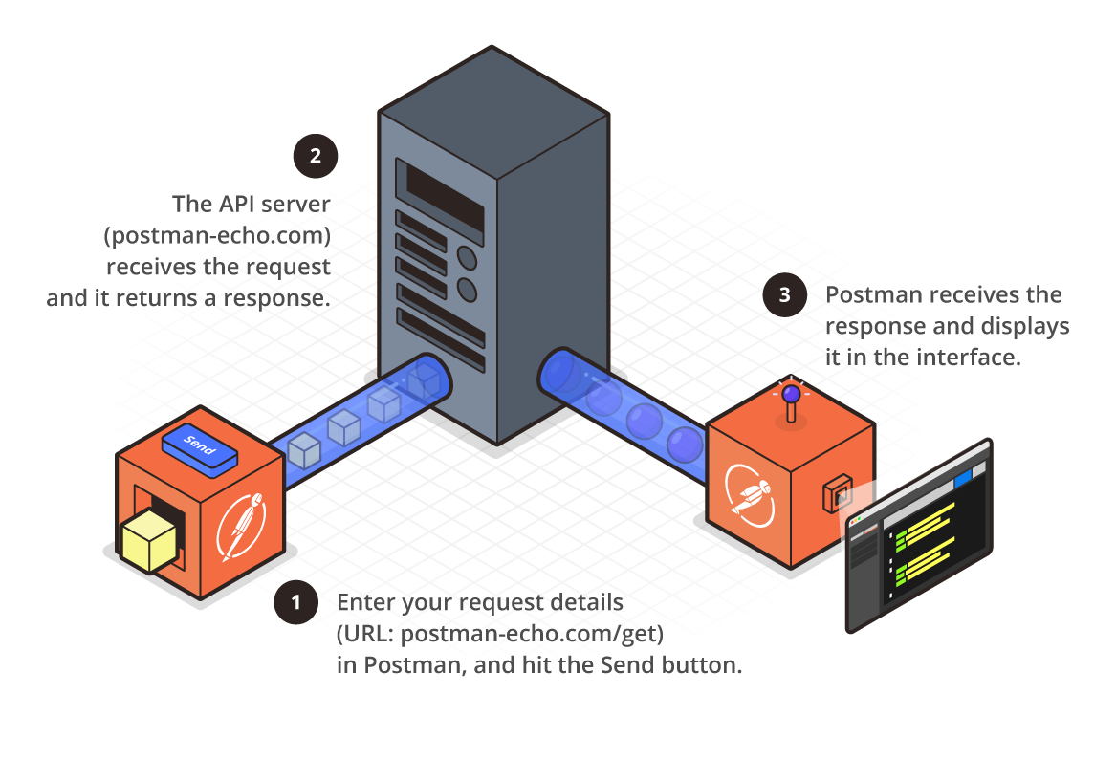[Create and send API requests in Postman](https://learning.postman.com/docs/sending-requests/requests/)